**Draggable object:**

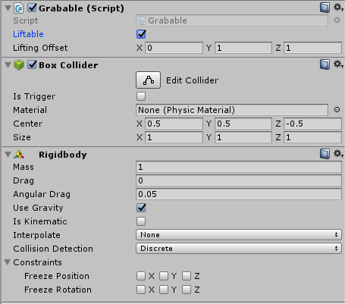

* Liftable: Defines if the player can hold the object and walk around freely, or only drag it around like a heavy object
* Offset: The offset of the object when it’s being lifted up in the air.

**Player settings:**

* Grab modifier: How much slower the player’s moving when he’s puling an object around. Works like a multiplier (so speed = speed*grabmodifier)
* Grab distance: how far away the player can grab stuff
* Throw force: The force multiplier used when the player releases an object. Affected by the player’s speed.

